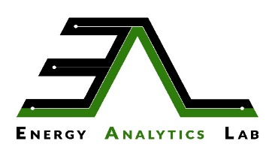 | 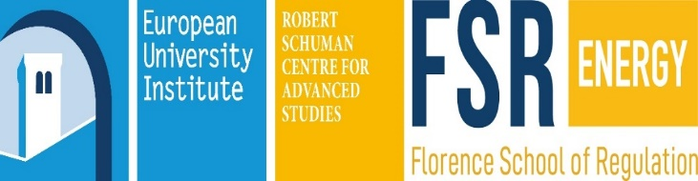 | 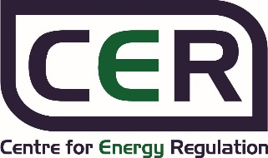

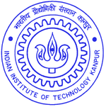 | Centre for Energy Regulation  &  Energy Analytics Lab  Department of Industrial and Management Engg.  Indian Institute of Technology Kanpur  Kanpur – 208 016 | 

Time: 09:30 AM - 01:00 PM | Date: 10th Oct 2018 | Venue: Department of IME, IIT Kanpur
Day 1 - Wednesday
09:30 AM - 10:00 AM | Registration and Welcome Tea & Coffee
10:00 AM - 10:05 AM | Lamp Lighting
10:05 AM - 10:12 AM | Welcome Address & Presentation by Dr. Anoop Singh, Coordinator, CER, IITK
10:12 AM - 10:19 AM | Address by Director, IIT Kanpur
10:19 AM - 10:26 AM | Address by Chairman, Board of Governors, IIT Kanpur
10:26 AM - 10:33 AM | Address by Mr. Gavin McGillivray, Head of DFID, India
10:33 AM - 10:43 AM | Keynote Address by Shri P.K. Pujari, Chairperson, CERC (Chief Guest)
10:43 AM - 10:48 AM | MoU Signing Ceremony between IITK and FSR
10:48 AM - 11:03 AM | Presentation of Mementos to the Dignitaries by Director, IIT Kanpur
11:03 AM - 11:08 AM | Launch of EAL Portal and Release of EAL Newsletter
11:08 AM - 11:18 AM | Inauguration of CER & EAL Lab - Ribbon Cutting Ceremony
11:18 AM - 11:32 AM | Unveiling of CER & EAL Stone Plaque and Group Photo
11:32 AM - 11:52 AM | Tea & Coffee Break
11:52 AM - 12:52 PM | Panel Discussion: Way forward for Regulatory Reforms in India
Invited Panelists | CER's Objectives and Activities: Dr. Anoop Singh, IIT Kanpur (Moderator)  Shri P.K. Pujari, Chairperson, CERC (Chair)  Prof. Jean-Michel Glachant, Director, Florence School of Regulation  Shri Raj Pratap Singh, Chairman, UPERC  Shri Alok Kumar, Chairman, UPPCL  Shri. S. N. Goel, CEO & MD, IEX  DFID, India  WB/ADB
12:52 PM - 01:00 PM | Vote of Thanks, Closing Remarks, Dr. Anoop Singh, Coordinator, CER, IITK and Presentation of Mementos to the Panelists by Director, IIT Kanpur
01:00 PM Onwards | Lunch
Inauguration Ceremony (Draft Agenda)

Centre for Energy Regulation

Department of Industrial and Management Engg.
Indian Institute of Technology Kanpur
Kanpur – 208 016

CER-FSR Symposium "Future of Utilities: International and Indian Perspectives"
(Draft Agenda)

Time: 02:30 PM - 05:00 PM | Date: 10th Oct 2018 |  | Venue: Department of IME, IIT Kanpur
02:30 PM – 03:30 PM | Talk on “EU Electricity Regulation - Present & Future” by Prof. Jean-Michel Glachant, Director, Florence School of Regulation
03:30 PM – 04:00 PM | Tea & Coffee break
04:00 PM – 05:00 PM | Talk on “Future of Utilities: Challenges and Solutions for the Indian Electricity Sector” by Dr. Anoop Singh Coordinator, Centre for Energy Regulation (CER), IITK
07:00 PM Onwards | Welcome Reception
Day 2 - Thursday
Time: 09:30 AM - 04:30 PM | Date: 11th Oct 2018 | Venue: Department of IME, IIT Kanpur
09:30 AM - 11:00 AM | Talk on “Digitalisation and what it means for the energy world” by Prof. Jean-Michel Glachant, Director, Florence School of Regulation
11:00 AM - 11:30 AM | Tea & Coffee Break
11:30 AM - 01:00 PM | Talk on “Innovation in network industries – challenges for energy regulation” by Dr. Pradyumna Bhagwat, Research Fellow, Florence School of Regulation
01:00 PM Onwards | Lunch
02:30 PM - 04:00 PM | Talk on “Integrated pathways to address firm and reliable energy access for all” by Swetha Bhagwat, Head of Global Relations, Florence School of Regulation
04:00 PM – 04:30 PM | Tea & Coffee break

Contact: Dr. Anoop Singh, Coordinator, CER
Email: cer@iitk.ac.in; Ph: (O): +91-512-259 6448

